Experiment 1
Simulation and Comparative Analysis of FDMA, TDMA and CDMA: Resource Allocation, User Capacity and Mobile-Generation Context

Objective 1: To estimate and compare the illustrative number of users supported by FDMA, TDMA and CDMA using the specified system parameters
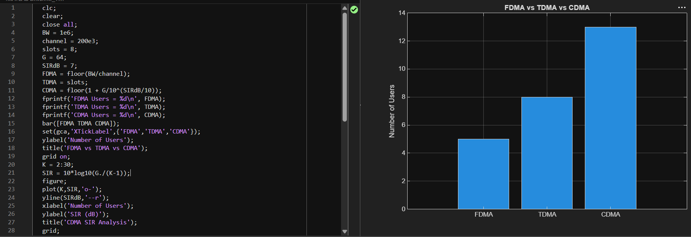

Objective 2: To analyze how the estimated CDMA signal-to-interference ratio changes as the number of simultaneous users increases. 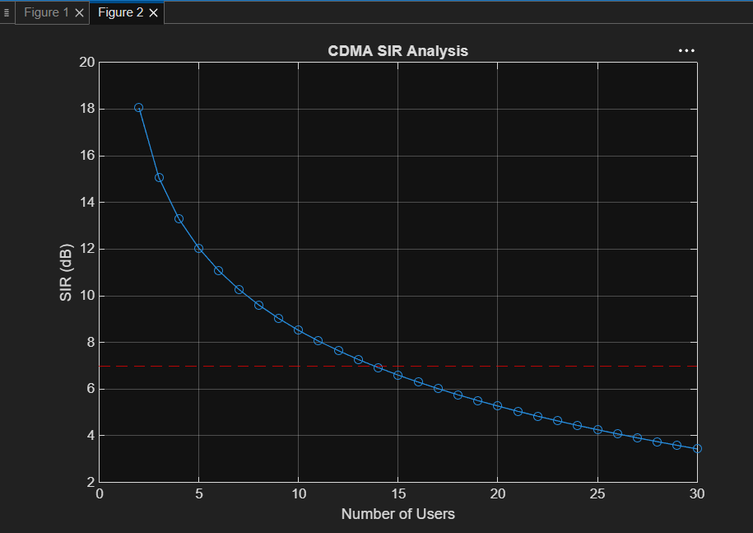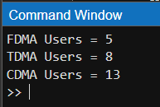

Objective 3: To relate representative multiple-access techniques to the evolution of mobile communication systems from 1G to 5G.
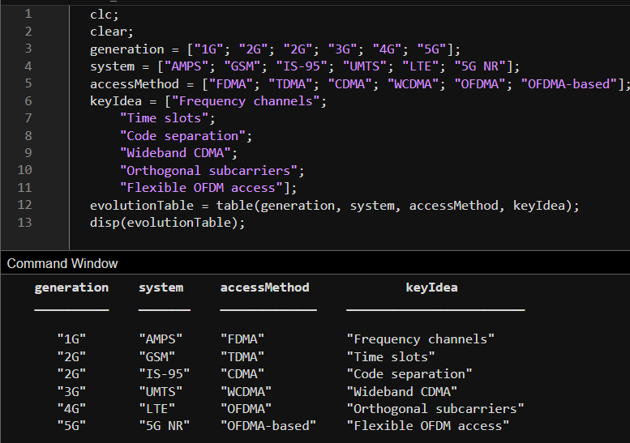

Objective 4: To visualize how FDMA, TDMA and CDMA assign frequency, time and code resources to multiple users.
